**CIS 229 – Python Programming – Programming Assignment**

**Animal Pens**

Overview

In this assignment, the student will write a Python script that uses mathematical assignments to solve a geometry problem.

When completing this assignment, the student should demonstrate mastery of the following concepts:

* General Python Programming Structure (Functions)
* Mathematical Assignments
* Mathematical Operators (+, -, *, /, %, **)
* Geometric Modeling
* User Interface Design – Console Prompting

Assignment

The following layout is given for an animal housing facility with undermined dimensions for the following labeled areas:

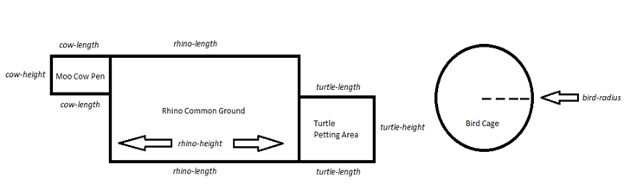

Although the exact lengths are unknown, the spatial layout of the facility will model this diagram exactly.

Write a Python script that prompts the user for the *cow-height, cow-length, rhino-height, rhino-length, turtle-height, turtle-length, and bird-radius.* After storing these values, perform whatever intermediate mathematical calculations are necessary to display information about the *area and perimeter for the Rhino Common Ground, Moo Cow Pen, Turtle Petting Area, and Bird Cage.* Additionally, calculate and display the *collective area, perimeter, and external perimeter* for the entire complex.

Properly document your solution and provide the user with a clean, intuitive interface.

Example Screen Shot #1

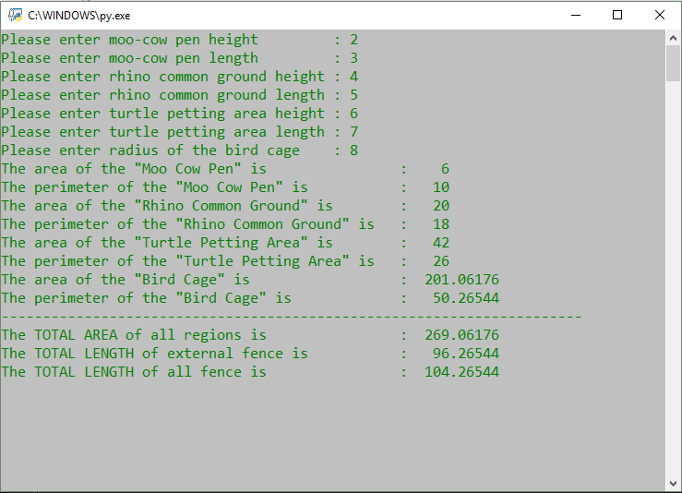

Assessment

This assignment will be assessed based on the provided grading rubric.